Task 1:

1. Queries:
2. The customer requests to search for books by category or by author.
3. Sales staff check the inventory of books.
4. The manager queries the book sales ranking list or the book category sales ranking list.
5. Customers buy according to the book category ranking list.
6. The manager inquiries about major customers, those with large order quantity or high order price.
7. Specification:

According to the scenario, there are three main entity sets that is Books, Customers, Order.

First, customers who want to buy books must register for a bookstore account (Reduce the possibility of websites being attacked), which contains the customer’s name, email, phone, and address.

Then customers can search for the author, the name of the book, or the recommended list based on the type of book, and customers can purchase books, which include the name, author, type, price, and format of the book (can be varied). The number of pages is required for paperback books and hardcover books, and the duration is for audio books.

When a customer purchases a book, an order will be generated, which contains the date, the number of books, and the total value of the books.

Finally, the customer could review the books he bought.

Therefore, the entity set customer includes the id attribute, the name attribute, the email attribute, the phone number attribute, and the address attribute. Book entity set includes id attribute, author attribute, genre attribute, price attribute, quantity attribute, format. The entity set Order includes attributes such as id, date, quantity, total values.

Regarding constraints, a customer can place multiple orders, but an order can only belong to one customer. An order has at least one book, but the book may not necessarily be purchased by the customer. It is not mandatory for customers to review books.

Task 2:

E-R diagram:

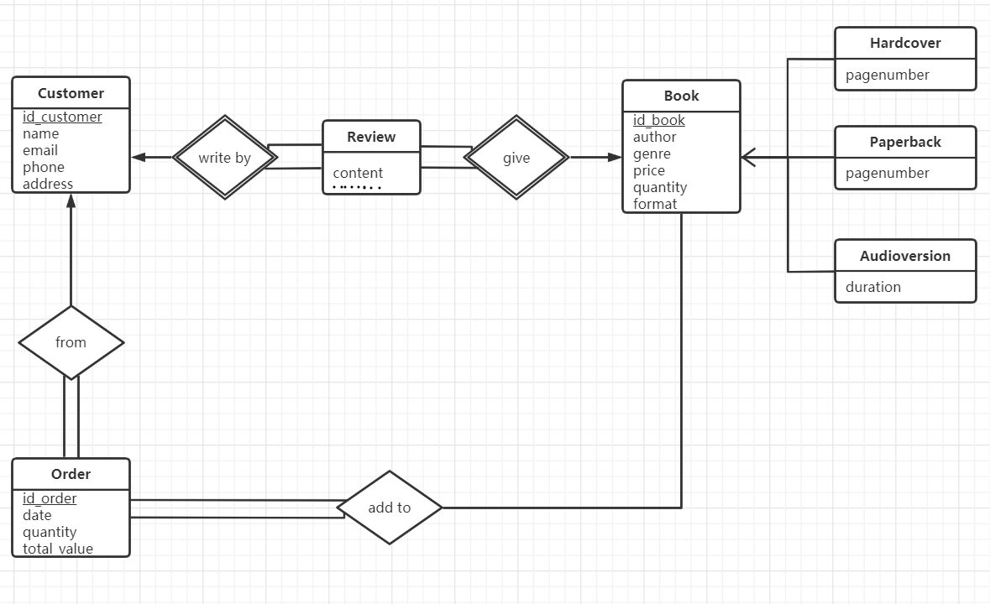

Task 3:

In this project, I first read the requirements carefully, and then extract the key words, such as nouns, and the relationship between nouns, and based on these, I establish some basic entities.

Then look for the relationships and constraints between each entity. Make a basic entity relationship diagram.

Finally, it was verified and compared with the original text repeatedly. What was missing.

In general, in Task 1, I feel that I still write the specification part not very professional and perfect. I personally think that the reason is that it takes more experience to convert theoretical knowledge into actual specification, such as how to make it easier for stakeholders to understand. In Task 2, I envisioned how to implement the actual database, and it was completed without major problems.

Through this assignment, I can understand how the database realizes the information management of the online bookstore. This process is very complicated. Consumers need personal information, and book information must be provided to consumers. We not only need to complete the required specifications, but also E-R diagrams, etc. Although it is not difficult to imagine, it is difficult to translate into text that people can read, especially for the first time. These gave me deeper thoughts. To complete the database must consider the reality.